

assignment=1

Modul 1



September 17, 2024

tops technoogy

[Company address]

1. What is software. what is software engineering?

Software refers to a set of instructions, data or computer programs used to operate computer and execute specific tasks.

# Software engineering is a branch of computer science that involves the design, development, testing, and maintenance of software applications.

It is systematic and disciplined apporch to software development that uses engineering principles and programming language to create software solutions for end users.



1. Explain types of software engineering.

It is a collection of data that is given to the computer to complete a particular task.

There are two types of software engineering.

1. System software
2. Application software
3. Drive software

System software

. operating system

. language processor

. device driver

Application software

.general purpose software

.customize software

.utility software

→ software is software that directly operates the computer hardware and provides the basic functionality to the users as well as to the other software to operate smoothly.

→operating system is the main program of a computer system. When the computer system ON it is the first software that loads into the computer’s memory. Basically, it managers all the resources such as computer memory, CPU, printer ,hard disk, etc.

→also known as this software is often considered a type of system software, device drives control the devices connected to a computer ,helping them perform their specific tasks.

1. What is SDLC? Explain each phase of SDLC.

→ SDLC (software development life cycle) is a process used by software engineers to design, develop, and test high quality software.

There are 6 phase of SDLC.

1.PLANNING

2. ANALYSIS

3.DESIGN

4.IMPLEMENTATION

5.TESTING & INTEGRATION

6.MAINTENCE

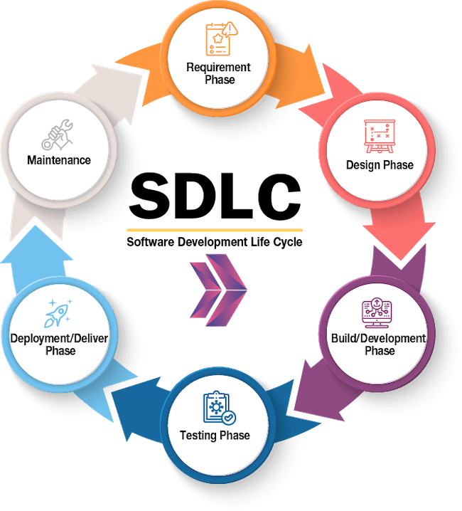

## PLANNING :

The first phase of the SDLC , where the team evaluates the project’s feasibility, costs, and resources.

## Analysis/requirement gathering:

The team gathers requirements from the client or stakeholders, and identifies their problems.

## Design:

The team transforms software specifications into a design plan , and ensures that the software meets the end-user’s requirements.

## Implementation:

The team begins building the programming for the software.

## Testing :

The team tests the product .

## Maintenance:

The software is maintained .

1. What is DFD? Create DFD diagram on flipKart.

A data flow diagram(DFD) is a visual representation of how data moves through a system or process.

DFDS are used to model and analyze system, and are often used in industries such as software engineering, business analysis, and database development.

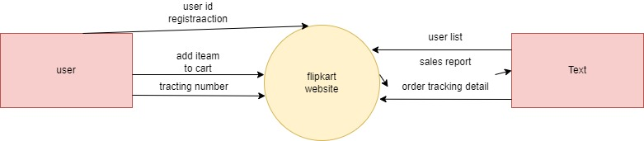

DFD level 0

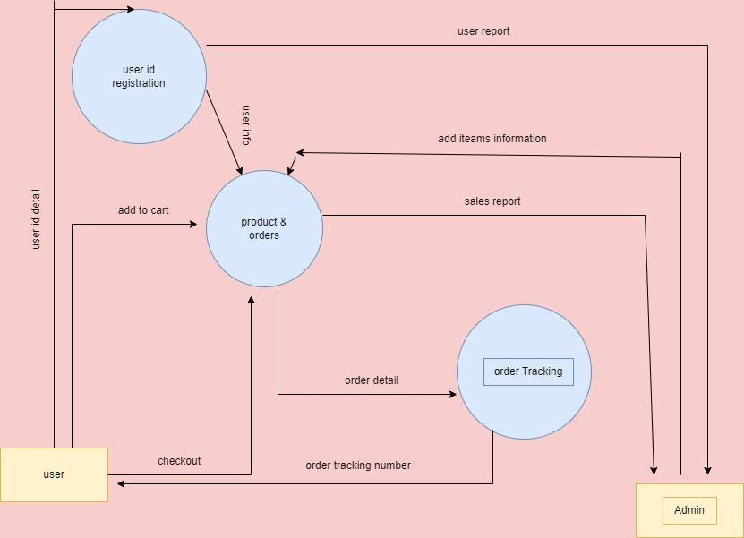

DFD level 1

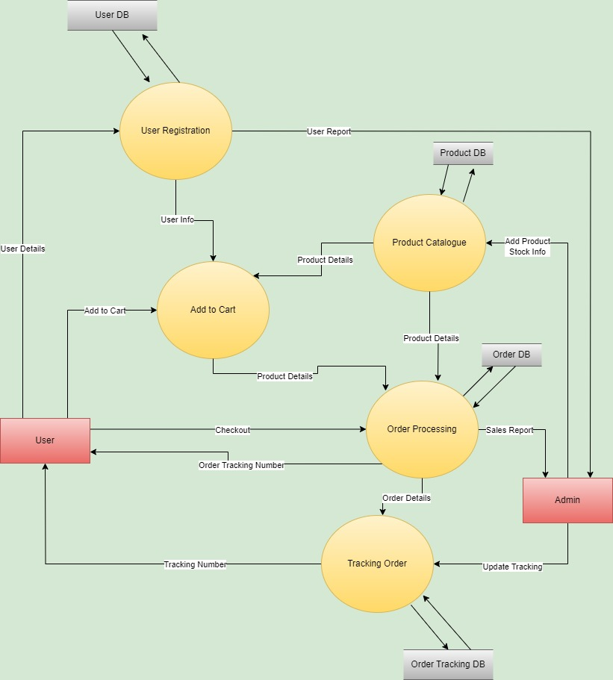

1. What is flowchart? Create a flowchart to make addition of two numbers.

A flowchart is a diagram that shows the step, sequence, and decisions in a process or workflow

It is a versatile tool that can be used to represent many different types of processes, such as manufacturing, administrative, service, or planning.

Components :

→ Ovals: indicate the start and end points.

→ Rectangles: represent process step by step.

→ Diamonds: Show decision points.

→ Arrows: indicated the flow of the process.

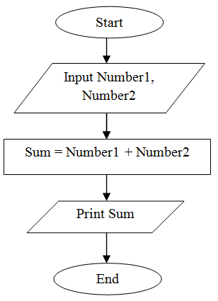

1. What is Use case diagram? Create a use case on bill payment on paytm.

A use case is a description of the different ways that a users can interact with an applications or product.

They define the various external entities that exist outside the system, as well as the specific interactions they have with the system.

External entities that interact with the system, such as users or other systems.

Specific actions or services the system performs , represented by ovels.

Use case diagram also show the relationship between actors and use cases, such as associated , generalizations, and dependencies.

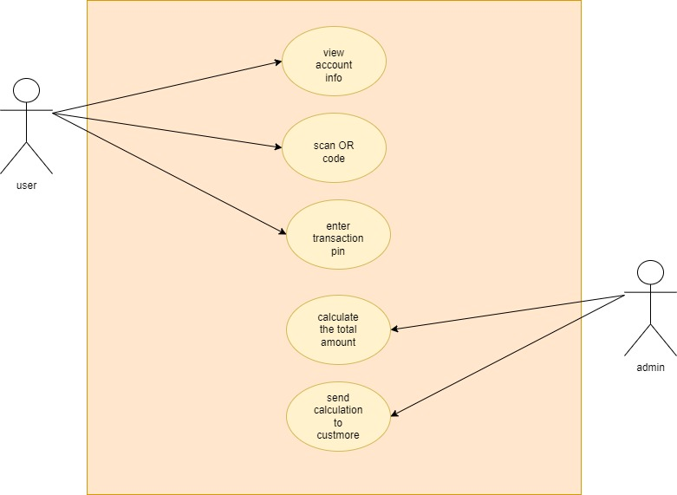

Use case diagram on bill payment